**“Mobile Applications Development”**

**course**

**a.y. 2014/2015**

**TRY THIS!**

**Design[1],[2]**

|  |  |  |
| --- | --- | --- |
| **Team Members[3]** | | |
| **Name** | **Student Number** | **E-mail address** |
| Mattia Ciolli | 219263 | Mattia93c@gmail.com |
| Michele Iessi | 222123 | iessimichele@gmail.com |

Strategy

# Product Overview

You want to relax, but you don’t know what to do. TryThis will help you choose what to watch, listen or play comparing your own personal tastes with other users’ preferences. TryThis is for everyone who wants to relax in his/her spare time. Just add your preferences and get started with an easy research which presents to you all the possible alternatives to your main band, favorite movie... Moreover it gives you the possibility of sharing your new discoveries on social networks and add them to your favorites.

## Competitors

TryThis is unique because it aggregates all the search functions of mobile and web apps, such as:

* Gnovies
* Bandhook
* Music Roamer
* Gnooks
* Gnovies
* SuggestMeMovie
* ReverbNation
* Pandora
* WhatShouldIReadNext
* WhichBook
* Every reddit.com’s section dedicated to suggestions about movies, music, books, games and tv

# These web apps are quite similar to TryThis, but also very different. That is to say, they all offer the search functions of TryThis, but TryThis does more things:

* Offers the possibility to create an account for different users
* Offers the possibility to save your findings and preferences for future use
* Offers the possibility to share your findings and likings on major social networks
* Offers the possibility to read a small description of the selected finding, to further help the user in his journey to find his likings basing on his preferences

# User Research

This app wants to help people find new alternatives to their main tastes only in one tap, showing what people having similar preferences like. This app lets users discover new music, books etc… with only a simple tap. Obviously if he likes the new discover, he can add it to his favorites and share wherever he wants to.

## Persona

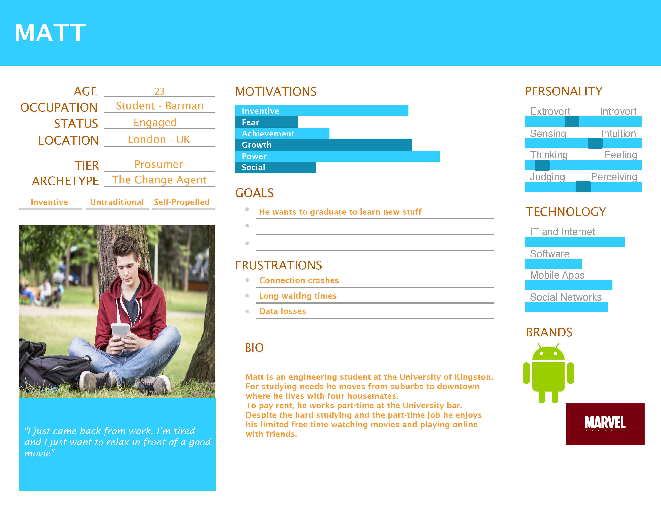

Scope

**Features**

* Possibility of creating an user profile in order to save personal preferences
* Preferences are divided into categories
* Suggestions are based on users' preferences
* Suggestions given by genre
* Sharing discoveries on major social networks

**Scenarios**

Matt comes home from his daily lessons. He's tired, but it's only 6 PM so he doesn't feel like going to work already. His pub work will begin at 9:30 PM, but he needs to get there for 9:00.

What can he do? 3 hours pass slowly, if you wait just by watching your ceiling…

So he picks his smartphone and proceedes opening TryThis!. He logs into the app and asks it: Suggest me something to watch, to play or to listen to!

The application quickly gives him back a result, based on the research Matt performed. TryThis!, infact, finds tastes he has with our database and gives back a series of results. It's a portal you can use for asking the entire world a suggestion.

He looks at the first items in the list and finds a movie he has never seen but he always heard good things about that. What better occasion is it to give it a try?

Matt finally turns on his PC and logs into Netflix. He spends 2 hours watching the movie, and that gives him almost 1 hour to get ready for work. But before doing this, he opens TryThis! again to update his preferences. He really liked that movie, so better tell it to the app, so he can suggest it to who will be bored in the future. His Facebook friends will also see that he really liked that, cause he just shared his feedback on his Facebook wall!  
  
After prepairing and getting ready for work, he leaves. While driving to the pub where he works, he is still thinking that movie was truly a big piece of work, even a masterpiece. He will surely tell his coworkers about it and, moreover, about how he found it.

Simple, TryThis.

Structure

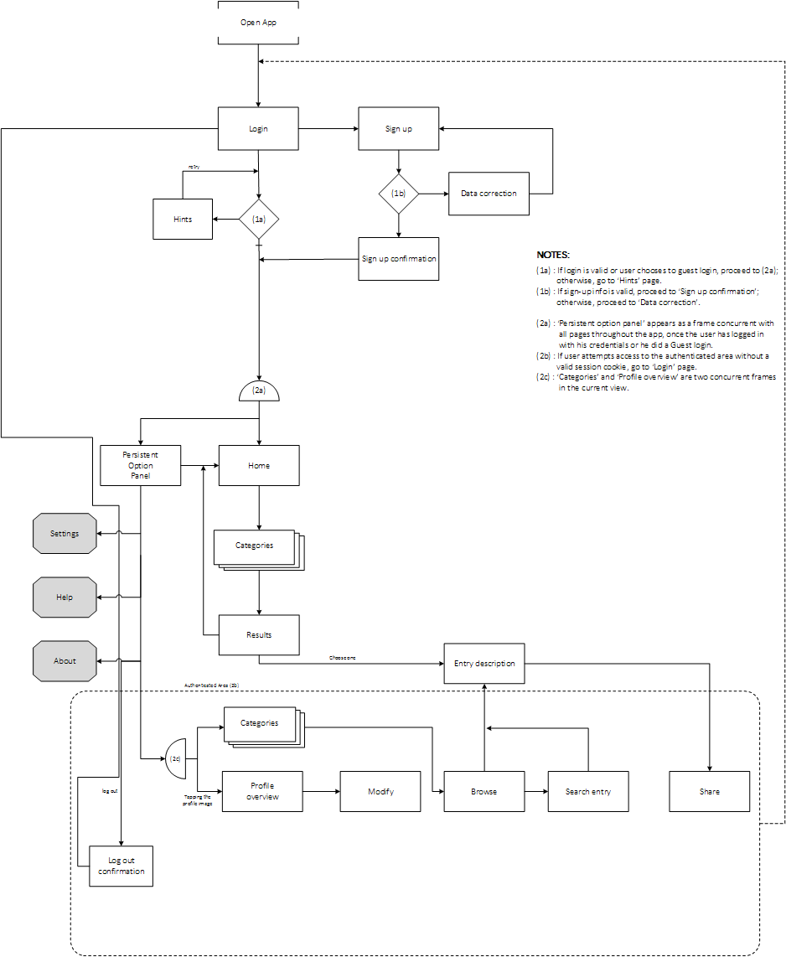

# Navigation model

The first part is a normal login procedure and a signup section. In both cases there are checks to maintain integrity. The login procedure can be used in two ways: logging in with an existing account or as a guest. Guests cannot save their preferences and thus they can only see the top content for each category.  
There is a Persistent Option Panel which appears once tapped a button on the screen. It contains many views, mostly to tweak app settings/looking for help or logging out. Logged in users will also have the possibility to check their accounts.  
TryThis! Function, once tapped its button, gives the user a suggestion chose between all categories.  
From Home the user can browse categories and look for suggestions.  
Logged in users will also be able to modify their personal info and have access to their account’s stats. They will also be able to browse into categories looking for already marked entries and modify their likings if they want.  
Logged in users, moreover, have the possibility to share their findings on major social networks, such as Facebook, Twitter and GooglePlus.

**Data**

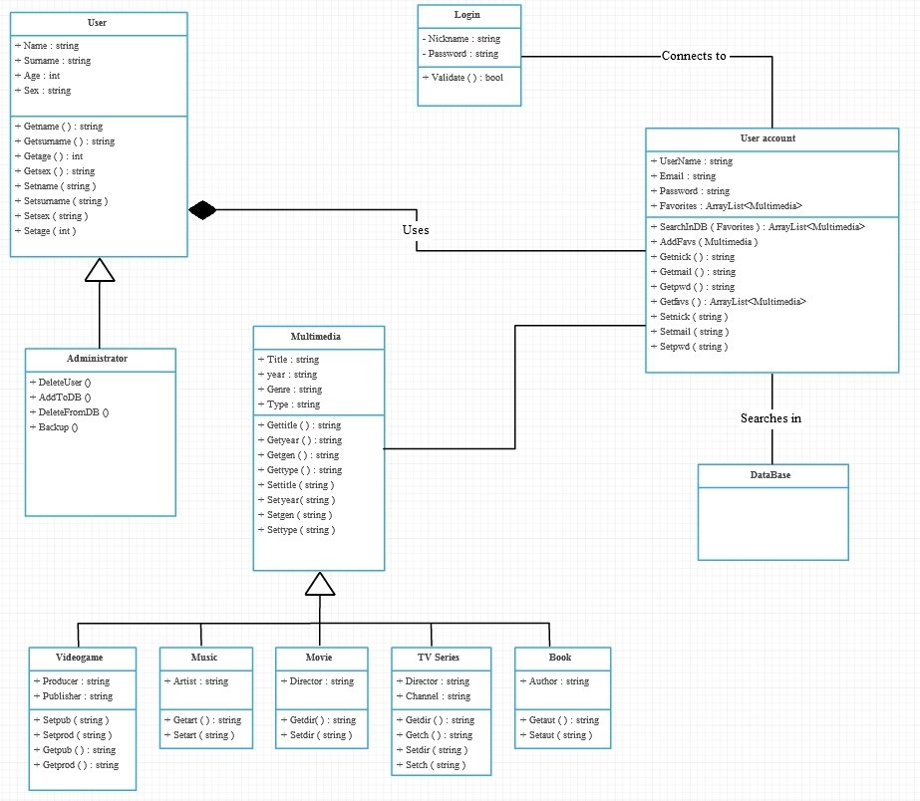

Skeleton



We decided to choose a minimal design to be more easy to use, using views through which any user could navigate without problems.

In the beginning we were about to make the filter view appear after a lateral swipe, but then we opted for a simpler and clearer method, because in that way the view would have had too many things. Furthermore, the new method is always visible and so it’s easier to access. We opted for static filters: user can choose among a list of preexisting filters. This will let getting results easier and faster than manually insert them.

Then, for the profile part: initially we decided to create that section using squares (sorta like Windows Phone menu), but then we opted for a more visible and updatable list pattern.

We inserted the “share” button in the detail view, in order to let users share their new discovers.

We use a sliding menu in order to not use a new view only for 4 links. Moreover it’s better to see.

Surface

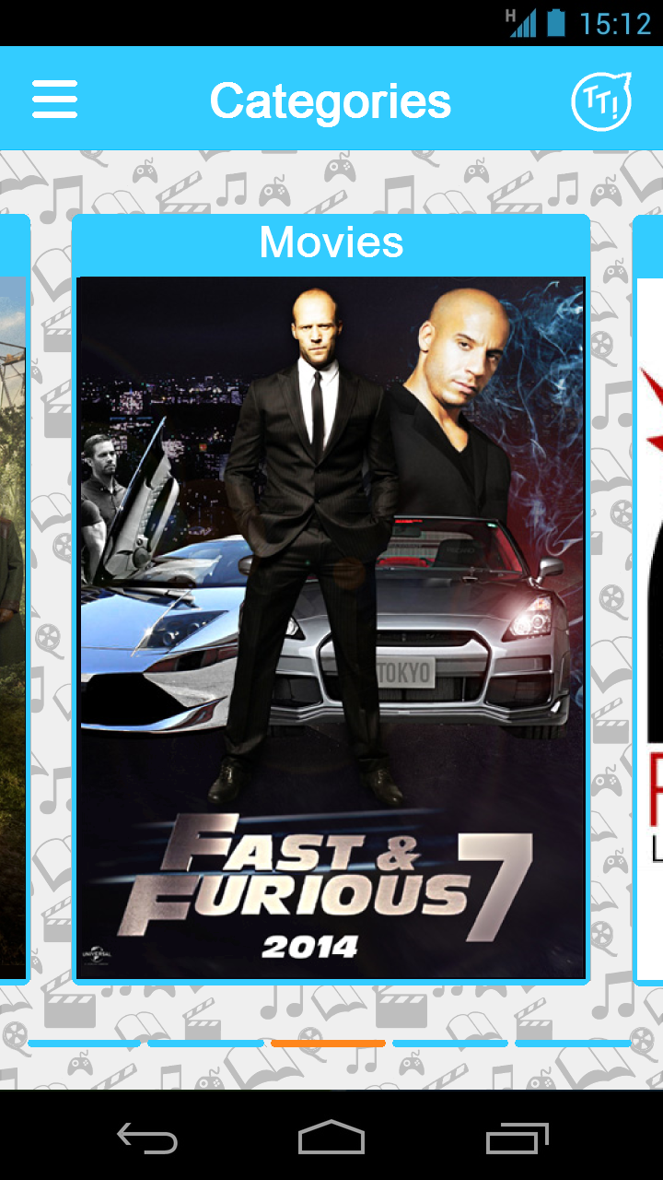

Colors:

Decided for a light blue because it grants good visibility with white text in all conditions, gives a sense of calm and it’s not aggressive or heavy for an interface.

For notifications or something to be highlighted we have chosen orange, light blue’s complementary.

For background we decided to put a texture with some logos to avoid an empty space or just a single color.

UI:

A carousel of 5 cards, one for each category (movies, tv series, books, videogames and music). On each card we have a randomly chosen picture which represents its category.

In the top left corner we have the settings/other button. If tapped it will show a menu from left with other link such as “about”, “account”, “logout” and “help”. This menu is reachable also with a left swipe to be more comfortable.

1. The max length of this document is 25 pages
2. The structure of this document is fixed, it cannot be changed in any way
3. The team leader is listed as first member in this list